#U49253220

#PAKALAPATI VIVEK

#Task 1

rm(list=ls())

A=6

groups<-((A*(A-1))%/2)

error.rate<- 1-(1-0.05)/6

error.rate = 0.84166666

#Task 2

summary(error.rate)

summary(error.rate)

Min. 1st Qu. Median Mean 3rd Qu. Max.

0.8417 0.8417 0.8417 0.8417 0.8417 0.8417

#Task 3

#make this example reproducible

set.seed(3220) #your last four digits of the U number

#create the dataset

data <- data.frame(C = runif(20, 2, 5), #control group

T1 = runif(20, 3, 5), #we have 5 different treatments

T2 = runif(20, 3, 6),

T3 = runif(20, 4, 6),

T4 = runif(20, 2, 6),

T5 = runif(20, 2, 5))

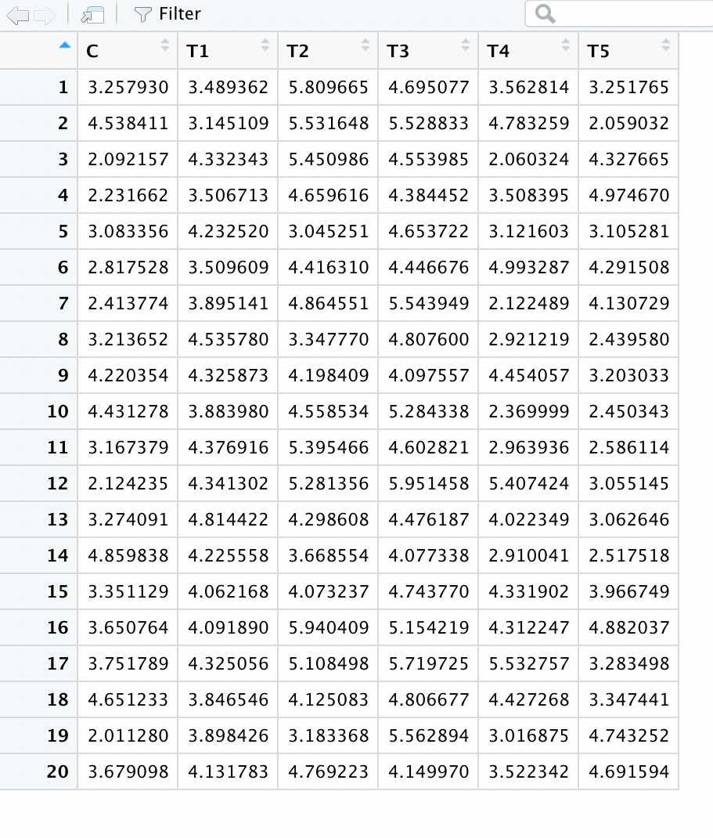

# Task 4

install.packages("gather")

install.packages("DescTools")

library(DescTools)

library(gather)

install.packages("tidyr")

library(tidyr)

group2=gather(data)

# Task 5

aovresult=aov(value~key, data=group2)

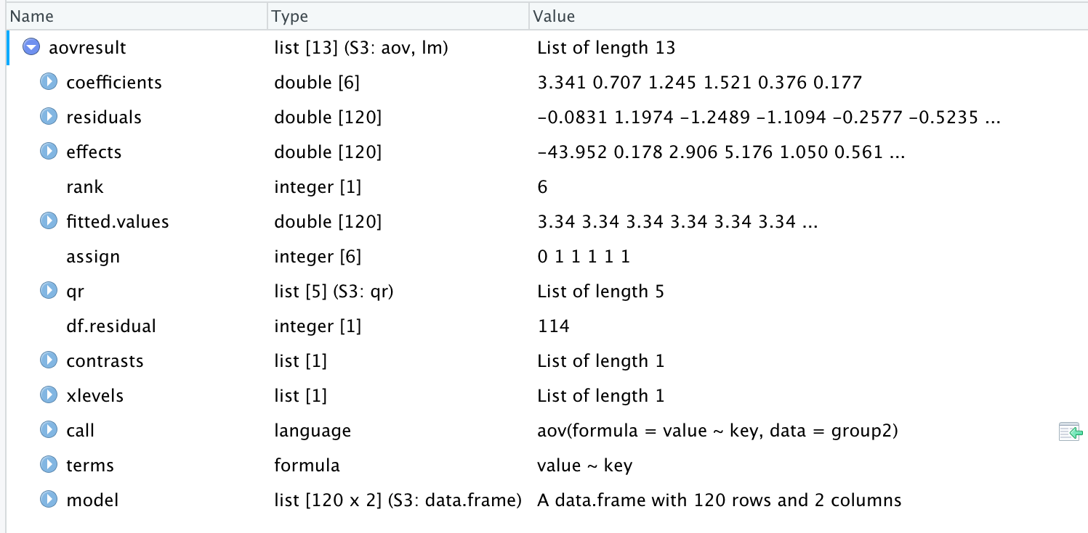

# Task 6

summary(aovresult)

summary(aovresult)

Df Sum Sq Mean Sq F value Pr(>F)

key 5 56.45 11.290 18.08 3.57e-13 ***

Residuals 114 71.19 0.624

---

Signif. codes: 0 ‘***’ 0.001 ‘**’ 0.01 ‘*’ 0.05 ‘.’ 0.1 ‘ ’ 1

# Task 7

# We can run the post-hoc tests to determine the groups are significant.

# Task 8

#TukeyHSD

TukeyHSD(aovresult)

> TukeyHSD(aovresult)

Tukey multiple comparisons of means

95% family-wise confidence level

Fit: aov(formula = value ~ key, data = group2)

$key

diff lwr upr p adj

T1-C 0.74194679 0.01756195 1.46633163 0.0413747

T2-C 1.22477600 0.50039116 1.94916084 0.0000462

T3-C 1.82490867 1.10052383 2.54929351 0.0000000

T4-C 0.15524963 -0.56913521 0.87963447 0.9892589

T5-C -0.01055013 -0.73493497 0.71383471 1.0000000

T2-T1 0.48282921 -0.24155563 1.20721405 0.3881885

T3-T1 1.08296188 0.35857704 1.80734672 0.0004472

T4-T1 -0.58669716 -1.31108200 0.13768768 0.1839559

T5-T1 -0.75249692 -1.47688176 -0.02811208 0.0368392

T3-T2 0.60013267 -0.12425217 1.32451751 0.1644506

T4-T2 -1.06952638 -1.79391122 -0.34514154 0.0005489

T5-T2 -1.23532613 -1.95971097 -0.51094129 0.0000387

T4-T3 -1.66965904 -2.39404388 -0.94527420 0.0000000

T5-T3 -1.83545880 -2.55984364 -1.11107396 0.0000000

T5-T4 -0.16579975 -0.89018459 0.55858509 0.9855250

# Task 9:

#summarize the result of the TukeyHSD test and visualize the findings (use plot(…))

summary(TukeyHSD(aovresult))

plot(TukeyHSD(aovresult))

> summary(TukeyHSD(aovresult))

Length Class Mode

key 60 -none- numeric

> plot(TukeyHSD(aovresult))

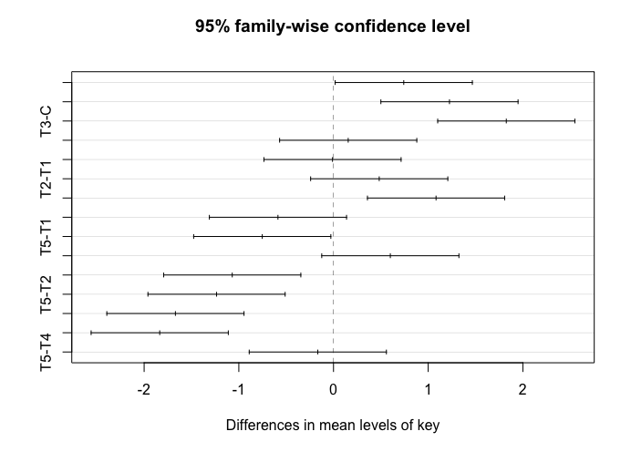

# Task 10:

install.packages("multcomp")

library(multcomp)

glht(model,linfct)

summary(glht(aovresult,linfct = mcp(group="Dunnett")))

# Taask 11

#Dunnett tool

library(DescTools)

DunnettTest(group2$value, group2$key)

DunnettTest(group2$value, group2$key)

Dunnett's test for comparing several treatments with a control :

95% family-wise confidence level

$C

diff lwr.ci upr.ci pval

T1-C 0.74194679 0.1050784 1.3788152 0.0161 *

T2-C 1.22477600 0.5879076 1.8616444 1.5e-05 ***

T3-C 1.82490867 1.1880402 2.4617771 2.3e-10 ***

T4-C 0.15524963 -0.4816188 0.7921180 0.9577

T5-C -0.01055013 -0.6474185 0.6263183 1.0000

Signif. codes: 0 '***' 0.001 '**' 0.01 '*' 0.05 '.' 0.1 ' ' 1

plot(DunnettTest(group2$value, group2$key))

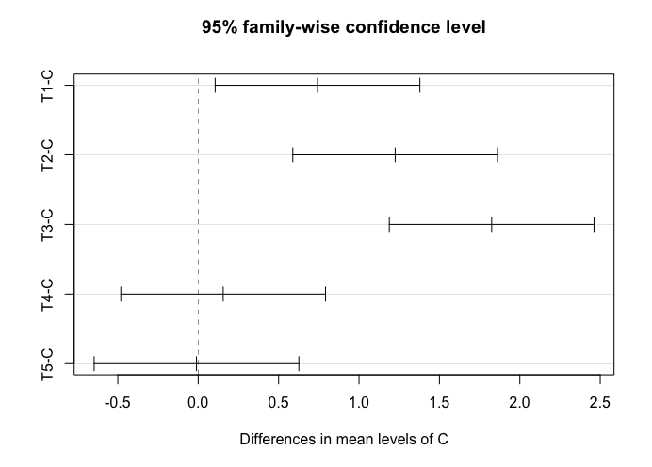

THANKYOU